IDEATION PHASE – DOCUMENT 2:

DEFINE PROBLEM STATEMENT
Date | 06 November 2025
Team ID | NM2025TMID08097
Project Name | To supply Leftover Food to Poor
Maximum Marks | 4 Marks

Title: Problem Definition for “FoodConnect – To Supply Leftover Food to Poor”

1. Objective
The main objective of this document is to clearly define the core problem, its causes, effects, and the technical rationale behind developing a Salesforce-based solution.
This step focuses on transforming the abstract idea from brainstorming into a structured problem statement that drives the entire project.

2. Context and Background
Food wastage and hunger represent two sides of the same societal issue.
- Every day, restaurants, hotels, and event organizers discard large quantities of edible food.
- At the same time, millions of underprivileged people suffer from malnutrition and starvation.
According to the Food and Agriculture Organization (FAO, 2023), approximately 40% of food in developing countries is lost before consumption.
In India, it is estimated that food worth over ₹90,000 crores is wasted annually, while over 190 million people go hungry daily.
The current system of food redistribution is largely manual — involving calls, text messages, and inconsistent coordination between donors, volunteers, and NGOs.
This causes:
- Delays in food pickup and delivery
- Spoilage of perishable food
- Lack of accountability and tracking

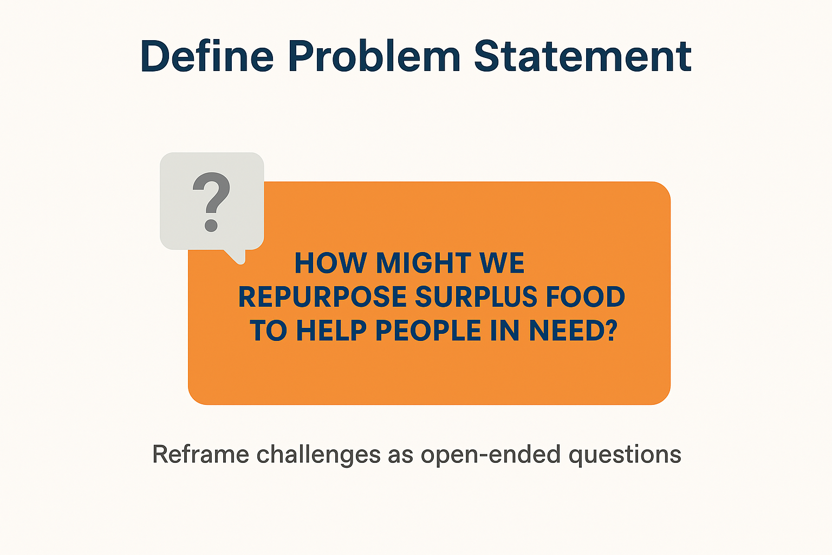

3. Problem Observation
During initial research and interviews with local NGOs, the following issues were identified:
- Manual Communication: NGOs and donors rely on phone calls or social media to coordinate donations.
- Lack of Real-Time Tracking: No proper method exists to track who collected, delivered, or received the food.
- Limited Data Transparency: NGOs cannot generate accurate reports on how much food was distributed or how many people were fed.
- Volunteer Coordination Issues: Difficult to assign and monitor tasks manually, leading to redundancy or confusion.
These observations underline the need for a centralized digital solution that can automate and streamline operations.

4. Core Problem Statement
“There is no unified digital system to efficiently collect, track, and distribute surplus food from donors to the needy, resulting in large-scale wastage, delayed logistics, and lack of accountability.”
This problem can be addressed using a cloud-based automation platform that connects all stakeholders in real time, provides task management, and ensures transparent reporting.

5. Project Goals
To solve the above-stated problem, the FoodConnect project was designed with the following specific goals:
- To minimize food wastage by connecting donors and NGOs on a unified digital platform.
- To automate the food collection and distribution process using Salesforce Flows and Triggers.
- To create a volunteer network with geolocation-based task assignment.
- To provide real-time dashboards for transparency and impact measurement.

6. Scope and Constraints
In-Scope:
- Real-time coordination between donors, volunteers, and NGOs
- Task management through custom Salesforce objects
- Reporting through dashboards and charts
- Basic automation with Flow and Apex Trigger
Out-of-Scope:
- Payment or monetary transactions
- Advanced inventory or stock management
- AI prediction of surplus food (future scope)
Constraints:
- Internet dependency for accessing Salesforce
- Limited technical literacy among NGO staff
- Data synchronization delays in rural areas

7. Technical Relevance
Salesforce was chosen as the foundation for its low-code platform and scalability.
The project utilizes:
- Custom Objects for data organization
- Flows and Triggers for automation
- Dashboard and Reports for visualization
- Public Groups and Profiles for secure access
This ensures that the system is both technically feasible and socially impactful.

8. Success Criteria
The success of FoodConnect is measured using four key performance indicators (KPIs):
KPI | Measurement Goal | Method of Evaluation
Food Waste Reduction | 30–40% decrease in wastage | NGO reports & donor logs
Delivery Efficiency | < 1 hour from pickup to drop-off | Task and Execution Details
Volunteer Engagement | 90% task acceptance | Volunteer object tracking
Transparency | 100% traceability of donations | Dashboard metrics

9. Expected Impact
The system is expected to:
- Improve operational efficiency of NGOs by 50%.
- Reduce food spoilage during redistribution.
- Strengthen trust between donors and NGOs through verifiable reports.
- Inspire expansion of food donation networks across India.

